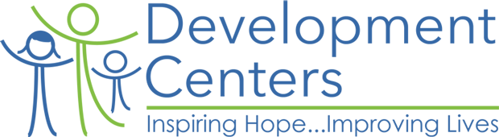

School Based Mental Health Services
“Our School Based Program is committed to providing the youth at select Highland Park, Detroit, and Redford schools with a continuum of care aimed at addressing barriers to learning.”

We continue to offer support to the students and families of our communities through telemental health services during the ongoing school closures

Through this, our team can “meet” with students and families through phone and video chat for intakes, assessments, individual and family therapy.

For more information, about services for students for Cody High School, please contact:
Sarah Waterman, LLMSW
Clinical Therapist – Cody High School
swaterman@develctrs.org

586-315-8918

